Environmental Science Syllabus 2015-2016
Apollo High School
Ms. Herrboldt
Course Outline:

Unit 1: Intro to Environmental Science/Environmental Issues
Topics: Energy transfer, populations, communities, food webs, food chains, ecology.

Unit 2: Water
Topics: Lakes, rivers, wetlands, groundwater, water quality, wastewater, oil spills.

Unit 3: Food Security
Topics: Bioengineering, GMO, land use, agriculture, pesticide, soil

Unit 4: Energy Crisis
Topics: Alternative Energy, Ozone, acid rain, global warming, greenhouse effect, pollution, weather, power plants, waste.

Unit 5: Waste Management
Topics: Recycling, waste, compost, garbage.

Unit 6: Wildlife Management & Minnesota Animals
Topics: Success stories, endangered or threatened species, conservation, fisheries
Topics: Birds, mammals, fish, reptiles, amphibians, tracks, skulls.

Unit 7: Zoos
Topics: Captive breeding programs, endangered species, enclosures.

Unit 8: Minnesota Plants and Outdoor Survival
Topics: Trees, flowers, edible plants, dichotomous keys, survival kit, compass, orienteering.

Required Materials:
Daily:
- Notebook or 3-ring binder with loose leaf paper
- Pencil or pen (no red ink)
On request:
- Colored pencils or markers
- Scissors
- Calculator
- Glue

Text:
HOLT Environmental Science by Karen Arms

Readings:
Be expert with Map & Compass: The Complete Orienteering Handbook by Bjorn Hjellstrom
Various Journal Articles

Videos:

An Inconvenient Truth
11th Hour
Human Footprint
Dirt: The Movie
Medicine Man
Food, Inc.
The Lorax
Planet Earth
Dances with Wolves
A Civil Action
Erin Brochovich

Required Web Resources
schoology.com
khanacademy.org

Assessments and Grading
Grading: A, A-, B+, B, B-, C+, C, C- ,D+, D, D-, F

Assessments:
- At least 1 project per trimester
- 1 exam per unit (8 total units)
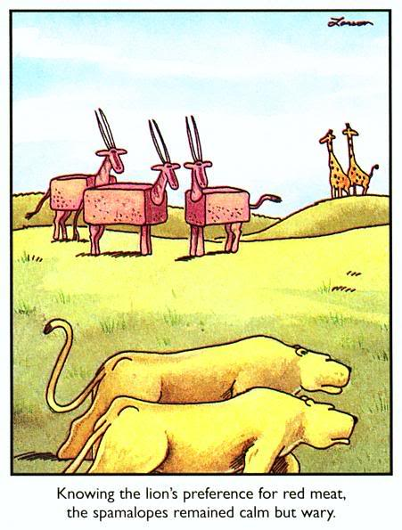
- At least 1 quiz per unit (vocabulary, pop, reading, video, etc.)
General Classroom Expectations:
- Arrive to class on time with necessary materials.
- Sit in assigned seat.
- Take all notes, complete all assignments.
- Work effectively in groups (student determined or teacher determined).
- Remain quiet while instructor is teaching.
- Keep all PEDs off or on silent. Use PEDs only when allowed by instructor.
- Be respectful of yourself, other students, and the instructor.

